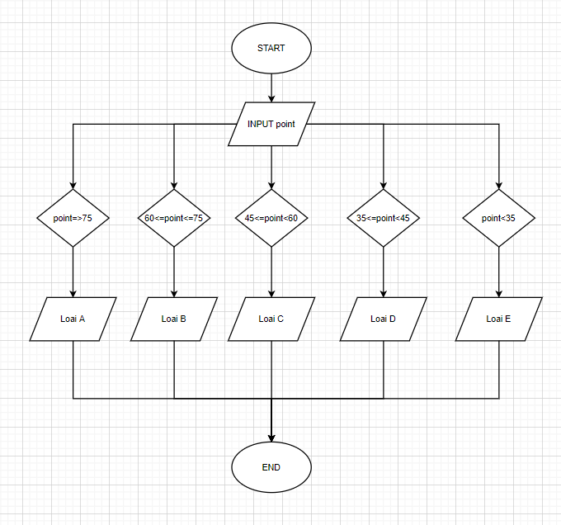

BEGIN

INPUT point;

IF point=>75

DISPLAY “ Xep loai A”;

ELSE IF 60<= point<75

DISPLAY “ Xep loai B”;

ELSE IF 45<= point<60

DISPLAY “ Xep loai C”;

ELSE IF 35<= point<45

DISPLAY “ Xep loai D”;

ELSE point<35

DISPLAY “ Xep loai E”;

END IF